

**Diagnostic Evidence Co-operative Newcastle**

Pilot study report - Diagnostic Evaluation of a rapid test for children with suspected RSV – The DEC RSV Study

**Long title - Clinical diagnostic accuracy evaluation of the Respiratory Syncytial Virus (RSV) component of the Roche cobas® Liat system on paediatric patients presenting with an acute respiratory illness and possible RSV cause**

*Authors:* Joy Allen

*Editor:*

*Last saved:* 24/06/2017 11:25 by

*File name:*

Table of Contents

1 Abstract 2

2 Introduction 3

3 Methods 4

3.1 Laboratory analysis 4

3.2 Statistical analysis 5

4 Results 5

4.1 Testing process 5

4.2 Study process: 6

5 Discussion 6

5.1 Technical issues with the cobas® Liat test 6

5.2 Study process 7

6 Conclusions 7

7 References 7

8 Appendix I: Standard Operating Procedure for Nasopharyngeal Sampling 7

9 Appendix II: SOP for discrepant sample result identification and storage 8

# Abstract

Objective

Respiratory syncytial (RSV) virus is a seasonal viral infection principally affecting infants and young children, and is responsible for a significant healthcare burden due to both outpatient visits and admissions in winter months[1]. The DEC RSV study aimed to evaluate the diagnostic performance of the RSV component of the Roche cobas® Liat influenza A/B and RSV test in UK paediatric wards and emergency departments. The aim of the pilot study was to test the feasibility of the study process, resource requirements and data management procedures for the main study to be conducted during the Winter 2017/2018.

Methods

A multicentre, diagnostic accuracy observational study was conducted during Winter 2016/2017 in two centres in the North East of England. Infants under 2 years old were eligible if they presented to the paediatric medical admissions units, wards or emergency departments with an acute respiratory illness and RSV was considered the diagnosis. Due to unforeseen technical equipment errors, delaying study recruitment, the study proceeded with a pilot phase to determine adequacy of process, resourcing and management.

Results

35 patients were recruited to the pilot phase during December 2016 – March 2017. Patients were easily identified as eligible, recruitment rates were higher than expected and study SOPs were deemed adequate and require minimal changes. Items for data collection, such as the time the laboratory test results were available were difficult to retrieve. Technical issue reporting and support mechanisms were identified to be a weakness and a possible cause for delays in the full study.

Discussion

Overall, the study process and management of the study worked well in the pilot phase. Slight refinements to the CRF to clarify the time stamp required for test result recording will avoid errors in data collection. Streamlining the process of technical error reporting will avoid delays in recruitment. Issues highlighted to the manufacturer regarding the wrong time displayed on the cobas Liat analyser will provide invaluable insight into the requirements for point of care test use in a busy assessment suite or paediatric ward of the UK NHS.

Conclusion

Although this study did not set out to have a pilot phase, the full clinical study will benefit from this early evaluation of study process. Small pilot studies provide a real life setting in which to evaluate whether the intervention under assessment and wider technical support is reliable enough to deliver for a full clinical assessment or indeed within a real-life setting. These are particularly informative for studies seasonal in nature whether timely recruitment is essential in order to meet recruitment targets.

The Roche cobas Liat RSV assays have since been CE marked therefore it is expected that the next phase will not experience the technical hold ups experienced in this phase. However, refinement to our reporting of errors and initiation of technical support will help to avoid any further unforeseen errors being detrimental to the study recruiting to target.

The DEC RSV pilot study showed that with refinements to the process, nurse resourcing, data management and improved technical support, the main study is feasible and recruitment to target should be achievable within a 3 month timescale.

# Introduction

Respiratory syncytial (RSV) virus is a seasonal viral infection principally affecting infants and young children, and is responsible for a significant healthcare burden due to both outpatient visits and admissions in winter months (Hall *et al,* 2009). RSV is the most important and common cause of lower respiratory tract infections (LRTI) in infants and young children (Tregoning *et al,* 2010), and may cause a range of presentations from a self-limiting illness through to severe bronchiolitis requiring management in intensive care.

RSV is highly transmissible in a hospital environment. Therefore initiation of prompt infection control practice when an infant is known to have the virus is key to limit its onward spread. Rapid viral testing at point of care may reduce the use of further diagnostic testing, inappropriate antibiotic usage (Doan *et al,* 2009), length of stay in hospital, and nosocomial infection by improving isolation resource use. Efficient use of isolation resources is of particular importance in busy UK National Health Service (NHS) acute care units. Furthermore novel specific RSV anti-viral treatments are currently being developed that are likely to be used clinically in the future depending on accurate and rapid diagnostic testing for greatest benefit. A test which can provide a quick and accurate result at the point of care can be a useful tool, potentially allowing for more appropriate use of isolation resources and resulting in a reduction of nosocomial infection.

The Roche cobas® Liat system provides a point of care diagnosis for influenza A/B and RSV within 20 minutes. The cobas® Liat system uses a PCR-based test, and thus has the potential to offer higher diagnostic sensitivity and specificity (Huang *et al,* 2015) than rapid-antigen based tests (Chartrand *et al,* 2015). Laboratory-based PCR testing is similarly accurate but the time for a result to be made available is often ½ a day or more because of factors such as transporting the sample to the laboratory, batching tests (necessary with some platforms commonly used by service laboratories), and processing time.

The investigators set out to conduct the first (to their knowledge) UK prospective, clinical evaluation of the RSV component of the influenza A/B test, on paediatric patients presenting with an acute respiratory illness and a suspected viral cause during winter months (Dec 2016 – March 2017). The main purpose of the study was to assess the diagnostic accuracy of the against the service laboratories current PCR method. A detailed description of this study can be found in the protocol v1.0 dated 19/10/16.

The investigators did not initially consider conducting a pilot phase of this study, however technical issues with the research use only cobas® Liat assays resulted in considerable delays which, due to the seasonal nature of the virus, jeopardised hitting the recruitment target. Therefore, the team decided to complete a pilot phase of the study to ensure refinement of the study process for the next winter season. The remainder of this report highlights the methodology and design of the pilot study, initial results from the test evaluation and the strengths and weaknesses of the study design and execution. The full evaluation will be refined as a result of key learnings from this pilot phase and how these will be implemented are described in this report.

# Methods

Patients were recruited from the paediatric emergency department, paediatric medical assessment suite and paediatric wards of the Great North Children’s Hospital, Royal Victoria Infirmary (GNCH RVI) and the paediatric wards of the Sunderland Royal Hospital (SRH) from December 2016- March 2017. Any patient presenting to these departments under the age of 2 years old, presenting with an acute respiratory illness and the attending clinician(s) considered that RSV infection was in the differential diagnosis. For these patients, their parents or legal guardians were approached for consent to the study by a GCP trained research nurse. Those for which sampling of respiratory secretions was considered to be contra-indicated by the medical team were not approached for consent.

If consent was obtained, nasal secretions were sampled from the participant by nasophyrangeal aspirate and flushed through with 3mls of sterile saline solution and split for testing with the cobas® Liat test and the standard respiratory panel test carried out in the laboratory (for full details see the Standard Operating Procedure used in Appendix I: Standard Operating Procedure for Nasopharyngeal Sampling).

The research nurse then extracted all relevant demographic data, presenting diagnosis, antibiotic use and length of stay data from the participant’s medical notes when this information became available.

The study protocol was approved by the East Midlands Leicester Central Research Ethics Committee (REC Ref 16/EM/0456), and all other necessary local approvals were obtained (NuTH R&D 8143, CHS R&I 14~04). The study was also deemed eligible for adoption onto the NIHR portfolio (CPMS ID 32674) and all recruited patients were recorded using the Central Portfolio Management system.

## Laboratory analysis

At the RVI and SRH, the specimens were tested for the routine respiratory panel, following existing laboratory protocols.

The RVI currently use Luminex® NxTAG Respiratory Pathogen Panel and currently report a panel of tests including:

* Adenovirus DNA
* Influenza A RNA
* Influenza B RNA
* Metapneumovirus RNA
* Parainfluenza 1 RNA
* Parainfluenza 2 RNA
* Parainfluenza 3 RNA
* Parainfluenza 4 RNA
* Rhinovirus/enterovirus RNA
* RSV RNA

SRH testing is performed at the Queen Elizabeth hospital Gateshead using Argene® and currently report a panel of tests including:

* Influenza A RNA
* Influenza B RNA
* RSV RNA

If there was a discrepancy between the results of the cobas® Liat and the reference test at each site, the remaining sample was retained and sent for testing with the reference test at the other site. This helped to determine whether the discrepancy was a result of the cobas® Liat assay or the local panel test used. The research nurses identified if there was a discrepancy by following the standard operating procedure outlined in Appendix II: SOP for discrepant sample result identification and storage.

RVI recruitment was carried out Mon-Fri 8-5pm however SRH limited recruitment to Mon-Thurs 8-5pm to avoid samples being tested using the Cephid Flu A/B RSV test which the QE Gateshead laboratory uses in order to provide a faster turn around time for results on weekends. To avoid research samples being misakeningly tested using the Cephid, the research nurses clearly mark the sample with a label denoted ‘DEC RSV study: test with Argene’.

## Statistical analysis

Two by two concordance tables were constructed within Microsoft Excel and all comparative accuracy analyses were carried out in RStudio Version 0.99.446 – © 2009-2015 RStudio, Inc.

A formal sample size calculation (detailed in the protocol v1.0 dated 19/10/16) was carried out for the full diagnostic accuracy evaluation which led to the target recruited size of 195. For this pilot study, we aimed to recruit 30 (15% of the total) patients over both sites (20 in GNCH RVI and 15 in SRH) to allow for a full trialling of the study process, resourcing and data management.

# Results

Thirty patients were recruited during December 2016 and March 2017. Twenty of those were at the RVI and fifteen at SRH. See Table 1 for demographic details.

Specimens were obtained for all participants using nasopharyngeal aspiration and tested via the cobas® Liat test as well as the standard laboratory testing procedures outlined in Subsection 3.1.

## Testing process

Two participants were removed from the diagnostic accuracy analysis due to incomplete results. These were both from the GNCH site.

|  |  |  |  |  |
| --- | --- | --- | --- | --- |
|  |  | Reference Standard | |  |
|  |  | Positive | Negative |  |
| Cobas Liat | Test Positive | 10 | 1 | 11 |
|  | Test Negative | 0 | 22 | 22 |
|  |  | 10 | 23 | 33 |

Table 1 2 x 2 table when initial cobas Liat result used

Number of repeat cobas® Liat results tests

Number of tests

Number of technical failures including error codes

Feedback from research nurses re use of test

Concordance results, overall and breakdown by site.

Research nurses from the Sunderland site reported black residue in … of the cobas® Liat cartridges but this did not seem to correlate with the invalid results and Roche later confirmed that this was normal precipitate.

## Study process:

*Eligible participant identification*

The eligibility criteria outlined in the protocol are easily understood and it is easy to identify infants who meet these requirements.

*Recruitment rates*

Our ethics approval did not extend to recording the number of families approached however the feedback from the research nurses (those doing consenting) was that there was a very high acceptability to the study. We estimated an 80% recruitment rate in the protocol and the feeling was that recruitment to the pilot study surpassed this. We have no concerns over gaining consent to the full study also as the procedure will not change.

*Data collection*

Most of the case report forms were filled out with ease, however a few items caused problem

The date at which the result was available to clinicians may be difficult to retrieve – consider revising in next phase

Data collection form in general thought to be straightforward, however can be quite laborious for clinical nursing staff in Sunderland Royal Infirmary. Next phase will allow data manager to pick up some of the routine clinical information retrieval.

*Study SOP adherence*

SOPs sample handling and for identification of discrepant samples were adhered to.

There was one instance in SRH where the laboratory test was not the chosen reference standard. This was identified by the research nurse however no mechanism was in place to get the sample re-tested. For the next season this will be addressed with clear instructions for the remaining sample to be retested using the Argene assay.

# Discussion

## Technical issues with the cobas® Liat test

Things to address for next season – technical error reporting to Roche: who to and what is the mechanism?

How do we ensure timely resolve to avoid significant delays to the recruitment?

## Study process

Overall the pilot study has highlighted that the study process and management work relatively well and only minimal changes need to be addressed for the full cohort study to be carried out during Winter 2017/2018.

Acceptance rate to the study was expectedly high and therefore the original recruitment target of 195 participants should be achievable.

Revisions to the CRF to ensure that the testing dates and times recorded are those

# Conclusions

To ensure the success of the full cohort study in the Winter 2017/2018, a short period of internal trailing of the cobas® Liat with the CE marked assays an appropriate period of time before recruitment opens will avoid any unnecessary initial delays to recruitment.

Clear procedures for reporting technical errors to Roche and timely response will also avoid unexpected delays when recruitment starts.

Clarifications to the testing date and time items within the CRF will ensure that the data collected will appropriately describe the time difference between the actionable cobas® Liat RSV test result and the laboratory reference test.

# References

References

1. Hall, C.B., et al., *The Burden of Respiratory Syncytial Virus Infection in Young Children.* New England Journal of Medicine, 2009. **360**(6): p. 588-598.

# Tables

|  |  |  |  |
| --- | --- | --- | --- |
|  | **All sites** | **GNCH** | **SRH** |
| **Age (months)** |  |  |  |
| mean (standard deviation) | 6.8 (5.4) | 7.4 (6.4) | 5.9 (3.8) |
| median | 6 | 6 | 5 |
| **Length of stay (days)** |  |  |  |
| mean (standard deviation) | 3.9 (3.9) | 4.5 (3.0) | 3.3 (4.7) |
| median | 2.5 | 4.7 | 2.3 |
| **Admission diagnosis** |  |  |  |
| Bronchiolitis | 26 | 12 | 14 |
| LRTI | 5 | 5 | - |
| Viral-induced wheeze | 1 | 1 | - |
| viral illness | 1 | 1 | - |
| Increased work of breathing | 1 | 1 | - |
| Suspected Meningococcal sepsis | 1 | - | 1 |
| **Antibiotic prescription** |  |  |  |
| Yes, before PCR result available | 10 | 6 | 4 |
| No | 23 | 13 | 10 |
| Not recorded | 2 | 1 | 1 |
| **Antiviral prescription** |  |  |  |
| Yes, before PCR result available | - | - | - |
| No | 31 | 20 | 11 |
| Not recorded | 4 | - | - |
| **Discharge diagnosis** |  |  |  |
| Bronchiolitis | 20 | 11 | 8 |
| LRTI | 2 | 2 |  |
| Receiving further investigation | 1 | - | 1 |
| Viral illness | 4 | - | 4 |
| Bronc/ Viral illness | 1 | - | 1 |
| Not recorded | 7 | 6 | 1 |

Table 2 Participant demographics

# Figures

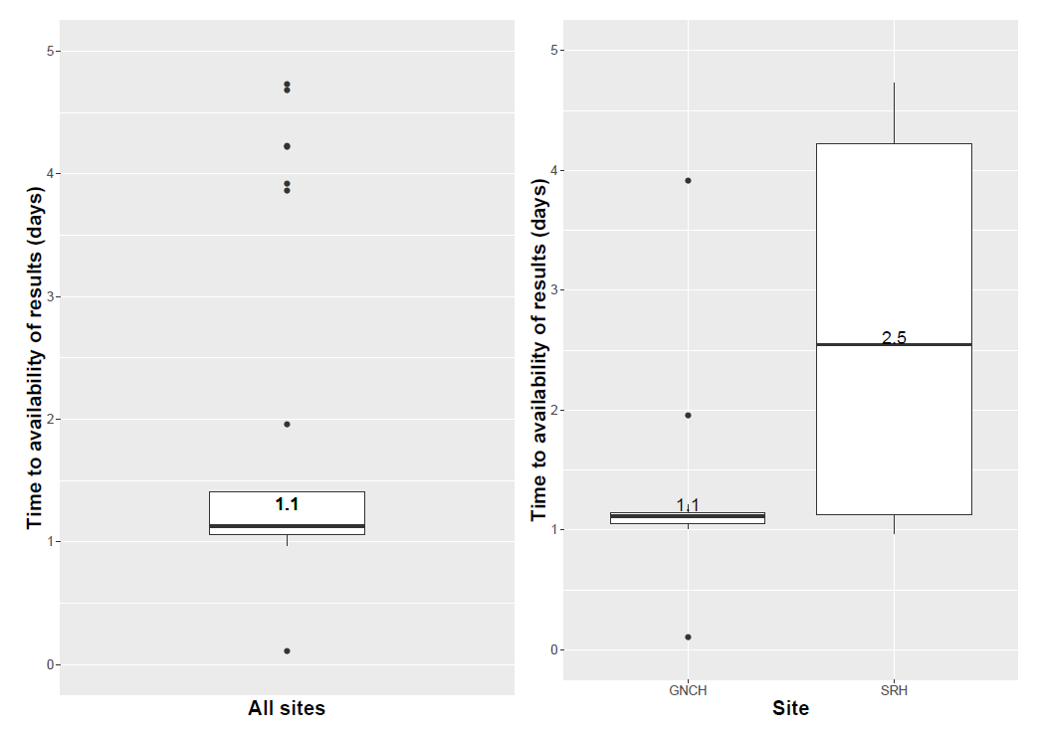

# Appendix I: Standard Operating Procedure for Nasopharyngeal Sampling

**Equipment**

Cobas Liat analyser

Cobas Liat cartridge including pipette

0.9% saline 5ml vial

Suction catheter – appropriate size for child

Trachea suction set (Mucus aspirator and trap)

Suction tubing

Hospital wall suction set at 15 – 20 KPa

**Procedure**

1. Remove Cobas Liat cartridge from fridge and leave at room temperature for 15 minutes

2. Check that the Cobas Liat analyser is operational

3. Check written informed consent in place

4. Explain procedure to carers (and child if appropriate)

5. Connect suction catheter to trachea suction set and wall suction tubing

6. Introduce suction catheter aspirator in to nostril and suction for 2 seconds to obtain secretions

7. Wash through the tubing with 3mls of 0.9% saline which is collected into trachea suction set.

8. Follow Roche cobas Liat instuctions on package insert for cobas Liat testing.

9. If RSV result is indeterminate, immediately retest.

10. Dispose of cartridge in biohazard waste bin as per local procedure.

11. Remaining sample to be transported to the virology lab in transport tube as per standard clinical procedure (include DEC-RSV label with form).

12. Complete all relevant paperwork

Note

If there is a spillage or the cartridge ruptures, there is a cleaning kit provided with the Roche testing kit.

# Appendix II: SOP for discrepant sample result identification and storage

The Virology lab in the XXX will be carrying out the standard, in-house RT-PCR test. The remaining respiratory sample will be stored by the virology lab for five days.

The points below outline the key steps taken by the research nurses to ensure that discrepant test results between the cobas Liat test and the RT-PCR lab test are flagged up within those 5 days. This will enable the virology lab to identify which samples need to be retained for further discrepancy analysis and which may be discarded.

* The lab RT-PCR test result will be available on e-record
* Research nurse should check every morning whether the RSV and influenza A/B results between the lab test and the cobas Liat test agree. If the first cobas Liat test flagged an invalid result, an error or was indeterminate for RSV and a second test has been carried out, it is the second test result which should be compared.
* The table below indicates when discrepancy tests or storage sample is required
* When the result nurse decides whether discrepant testing is required, please inform the laboratory by sending an email to XXX.
* Results of discrepant testing should be sent back to XXX. Section 3 of the CRF can then be updated following the results of the discrepant testing.

|  |  |  |
| --- | --- | --- |
| **Cobas Liat result** | **Laboratory RT-PCR detected** | **Discrepant RT-PCR testing required?** |
| **RSV** | | |
| RSV positive | yes | no |
| RSV negative | no | no |
| RSV positive | no | yes |
| RSV negative | yes | yes |
| RSV indeterminate  (on second test) | yes or no | yes |
| **Influenza A** | | |
| Influenza A positive | yes | no |
| Influenza A negative | no | no |
| Influenza A positive | no | Store sample for further analysis |
| Influenza A negative | yes | Store sample for further analysis |
| Influenza A indeterminate  (on second test) | yes or no | Store sample for further analysis |
| **Influenza B** | | |
| Influenza B positive | yes | no |
| Influenza B negative | no | no |
| Influenza B positive | no | Store sample for further analysis |
| Influenza B negative | yes | Store sample for further analysis |
| Influenza B indeterminate  (on second test) | yes or no | Store sample for further analysis |

|  |  |
| --- | --- |
|  | Results of tests agree, no need for further testing, sample can be discarded |
|  | Results of tests disagree, further discrepant testing required, sample must be stored |
|  | Result of second cobas Liat test is invalid, sample stored for any further analysis TBD |